**OPTI 340 Spring 2014**

**Midterm Exam #1**

Mar. 4, 2014

Open book (Fundamental of Lens Design, only)

Open notes, homeworks, design projects

Calculator allowed, No pre-programming of the calculator.

Tablet devices are allowed only for viewing handouts distributed in the class and notes taken by the tablet.

No Internet Connection.

Individual work only

Arizona Code of Academic Integrity applies

8:00 AM till 9:15 AM (1hour 15 min.)

3 problems

Professor Yuzuru Takashima

Alonzo Espinoza

**Problem 1 [20pts]**

Consider a plano-convex lens depicted in Fig. 1. The lens data are listed in Fig. 2 in a CodeV’s LDM (Lens Data Manager) format in units of mm. The index of refraction of the lens material is 1.5. The aperture stop is located at the surface 1. Surface 3 is a dummy surface where the marginal focal point is located. Surface 4 is a paraxial focal plane. The EPD (Entrance Pupil Diameter) is 10mm. The system is modeled for an on-axis field. Exact ray trace data of the marginal ray is tabulated in Table 1.

1. [5pts] Calculate optical path length along the marginal ray from surface 1 and 3.
2. [5pts] Calculate optical path length along the chief ray from surface 1 to 3.
3. [5pts] Does Fermat’s Principle hold true between surface 1 as a reference surface and the marginal focal point?
4. [5 pts] If Fermat’s principle holds true/false, please explain why.



Fig. 1

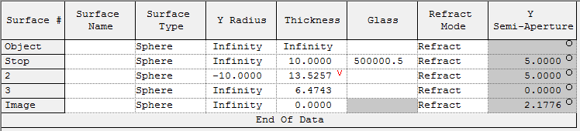

Fig. 2

Table 1. Exact raytrace data

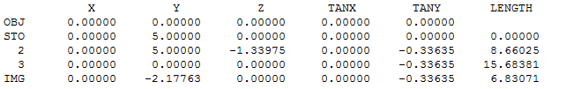

**Problem 2 [40pts]:**

Consider an optical system used under a one-to-one imaging condition depicted in Fig. A. The system consists of two positive thin lens elements having an equal focal length, f1 = f2. The index of refraction of the thin lens is n = 2. An object is located at –10mm measured from the first surface of the lens #1. The marginal ray height at the first surface of Lens #1 is 1mm. For simplicity, we assume zero air spacing between the thin lens elements.

1. [5pts] Calculate the focal length of the lens element #1, f1.
2. [5pts] Calculate conjugate factors C1 and C2, of the lens element #1 and #2.
3. [5pts] Calculate shape factors B1 and B2 of the lens element #1 and #2, for which the Seidel spherical aberration coefficient of each lens is minimized.
4. [5pts] Sketch the lens system. Cleary draw the shape of each lens element #1 and #2 based on the calculation. Draw a marginal ray. For the purpose of drawing the rays, add an appropriate thickness to the lenses.
5. [20pts] We compare the two-element design against a one-element design having the same system power and the same glass material. The one-element design has a minimum spherical aberration in the one-to-one imaging condition. How good is the two-element design, compared to the one-element design, in terms of the Seidel spherical aberration coefficient SI? Calculate a factor of improvement defined by, SI_TwoElement/SI_SingleElement.



**Fig. A**

**Problem 3 [40pts]:**

Consider an F/10 optical system having 3rd and 5th order spherical aberrations W040 and W060. The system is fully corrected so that the marginal ray has ZERO transverse aberration,  y(yp=1) = 0. The value of the aberration coefficient W040 is 1um.

1. [10pts] Plot a ray fan diagram at the paraxial focus for the fully corrected condition. Clearly mark the peak-to-valley values of the ray aberration y and its location on the yp-axis, yp*.
2. [5pts] Calculate the geometrical extent of the spot at the paraxial focus.
3. [20pts] Using the ray fan diagram, graphically estimate the amount of defocus so that the geometrical extent of the spot size is minimized under the full correction condition.

Hint: For simplicity, assume that yp* that satisfies the condition, , is a defocus-independent value.

1. [5pts] Re-calculate the geometrical extent of the spot for the amount of defocus calculated in part c.